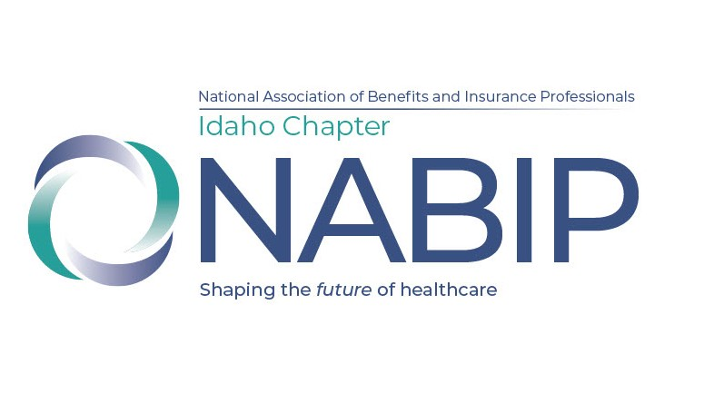

NABIP Idaho Chapter
Strategic Plan
2024-2025

NABIP Idaho MISSION STATEMENT:

Through education, advocacy and professional development, we will improve our members’ ability to meet the health, financial and retirement security needs of all Idahoans.

NABIP Idaho VISION STATEMENT:

Through the services of insurance professionals, every Idahoan will understand and have access to solutions for health, financial and retirement security needs.

2024-2025 NABIP Idaho GOALS

Goal #1: State chairs will have meaningful connection with local chairs, and will reach out within the first 60 days of new term and will continue with monthly or quarterly calls.

Goal #2: All NABIP Idaho board members will contribute to the NABIP PAC.

Goal #3: NABIP Idaho membership will increase by 20 members statewide.

Goal #4: Each state board member will invite a non-member guest to attend the NABIP
Idaho Health Symposium at the member price.

Goal #5: Increase our visibility in the general population and specifically among licensed
agents in the state.

Goal #6: NABIP Idaho Secretary will work with local chapters to ensure that updated chapter
leadership rosters are submitted by the end of April.

